ANNUAL REPORT 2025
Association for Supported Employment Europe (ASEE)
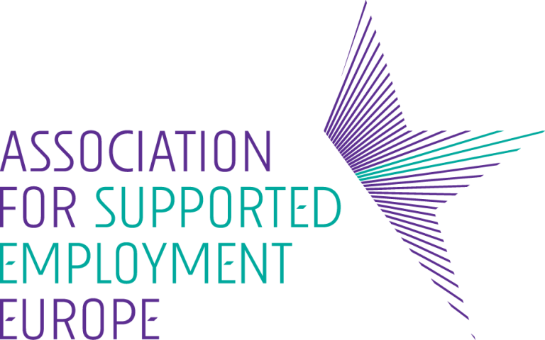

Easy-to-Read Summary


© European Easy-to-Read Logo: Inclusion Europe. For more information about Easy-to-read, see Inclusion Europe’s website: https://www.inclusion-europe.eu/easy-to-read/
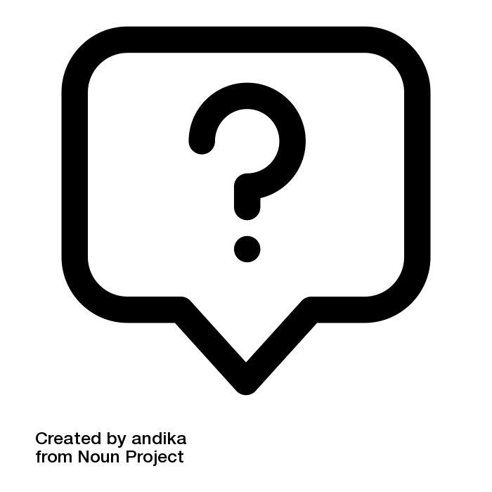
What is this report about?
This is the ASEE annual report for 2025.
ASEE stands for:
Association for Supported Employment Europe.
The annual report tells you what ASEE did in 2025.
It also tells you what ASEE plans to do in 2026.

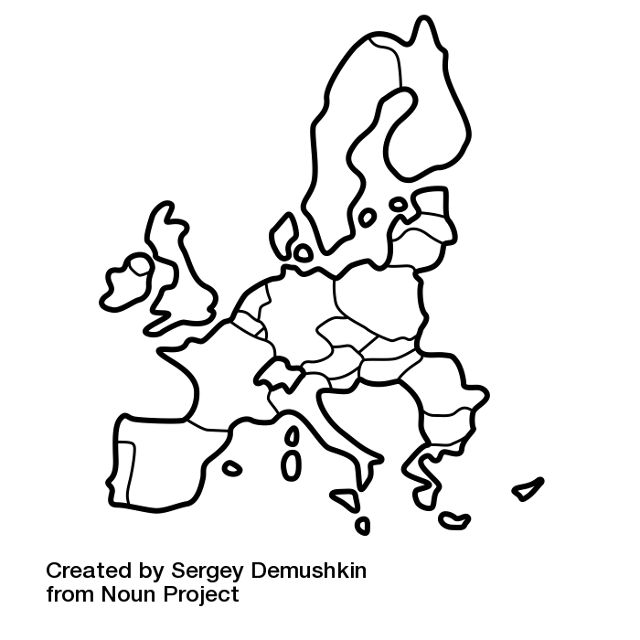
What is ASEE?
ASEE is a group of organisations
that work together.
These organisations are in 22 countries.

ASEE helps these organisations to give people
good support,
so they can find a job.

Supported Employment helps people find
and keep a real job,
with someone to help them.

ASEE also explains to people in the government
what Supported Employment is
and what these services need from government.

What happened in 2025?

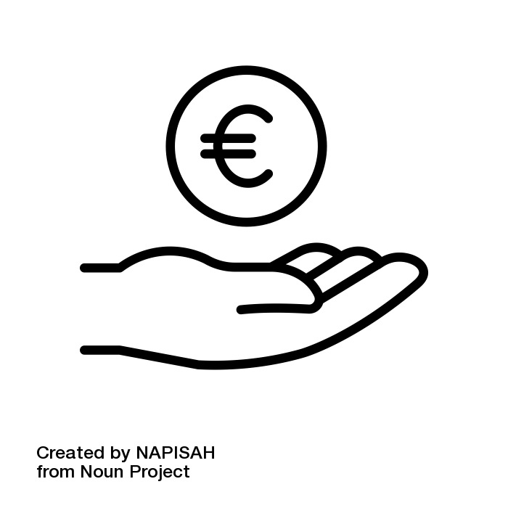
New money from the European Commission
ASEE asked for money
and the European Commission agreed to give it.
ASEE will get about 500,000 euros every year.
ASEE got the money in January 2026.
This means ASEE can grow
and do more work.

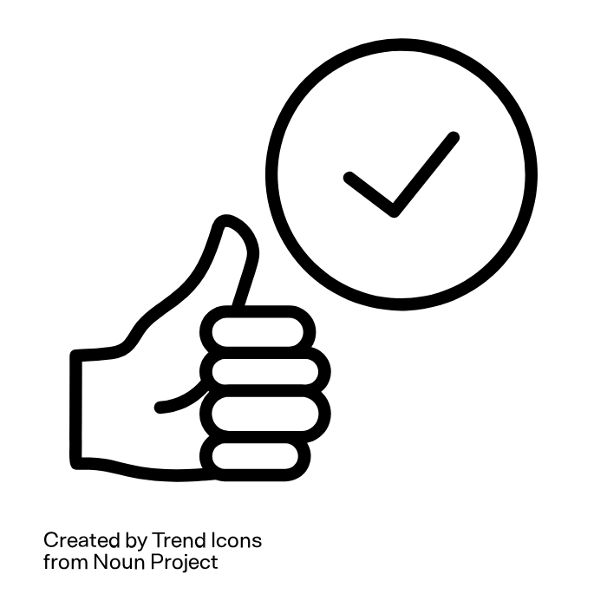
Quality Framework
ASEE has a document called the
Supported Employment Quality Framework.
We call it SEQF for short.
It helps organisations understand if they give good Supported Employment services
and how the services can be better.

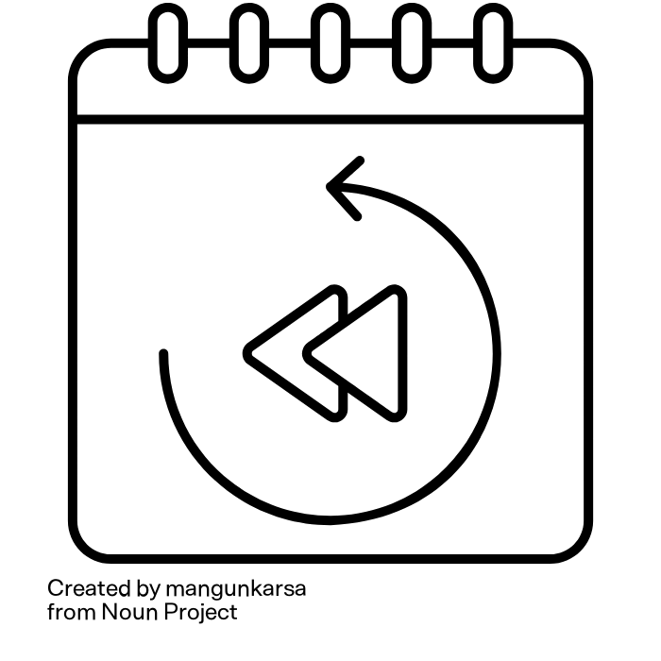
In 2025:
An organisation in Belgium was the first
to use the SEQF
to understand how good their services are
and how they can be better.

The SUPPORT Project
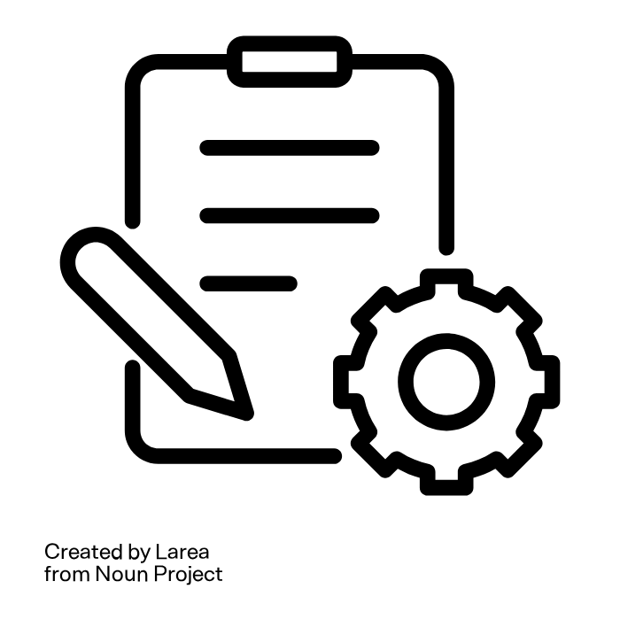
This activity will organise many events and
teach people how to provide good
Supported Employment.
The European Commission is funding it.
16 organisations from 9 countries
are working together
to help more people
find and keep real jobs.
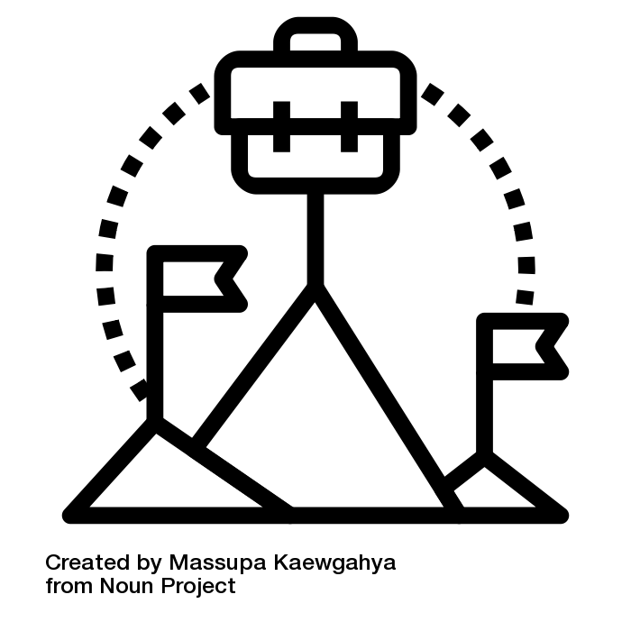
The BEO Project
BEO stands for Business Engagement Odyssey.
This project helped employers
include people in jobs
who need support.
In May 2025, there was a meeting in Lisbon, in Portugal.
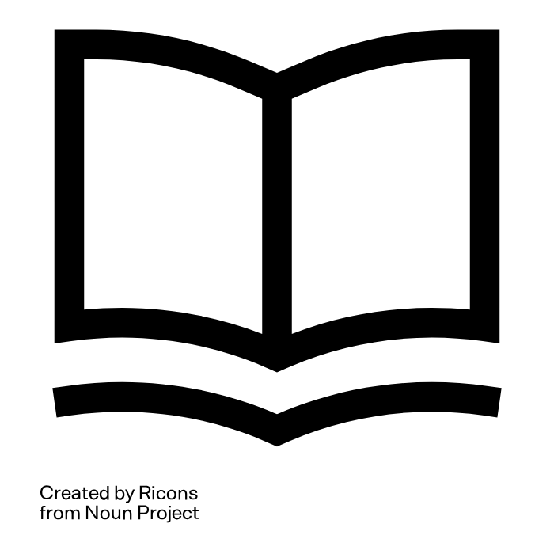
It thought people how to talk to employers.

A Guide was written to help employers
give people jobs and help them.

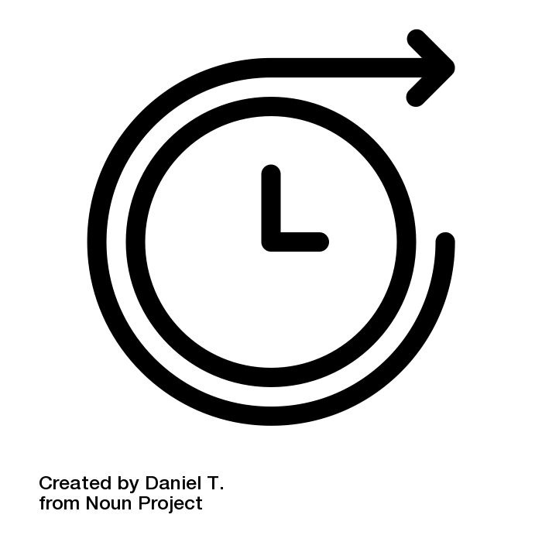
What will ASEE do in 2026?
ASEE will have new people
working for the organisation.


ASEE will explain to employers
and services helping people get jobs
what Supported Employment is
and how to use it.
ASEE wants to help more people
find jobs


Make the Quality Framework more popular
ASEE will help more organisations use the framework.
Organisations will translate the framework
into more languages.

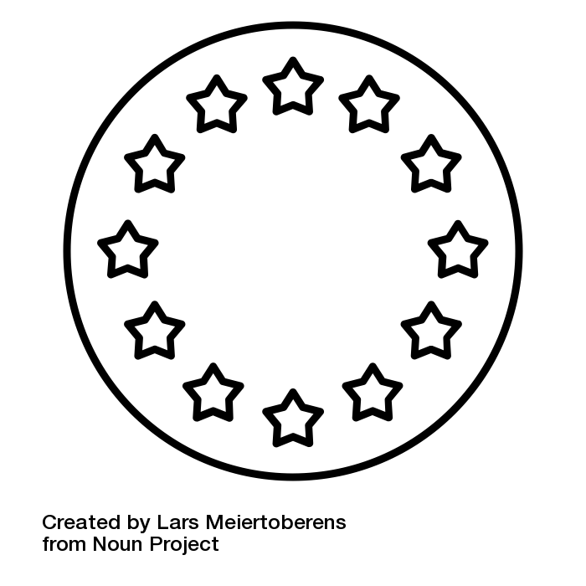
Work on European rules
ASEE will talk to people who make decisions.
ASEE will make sure Supported Employment
is understood as the best way
to help people who have difficulties to find work.

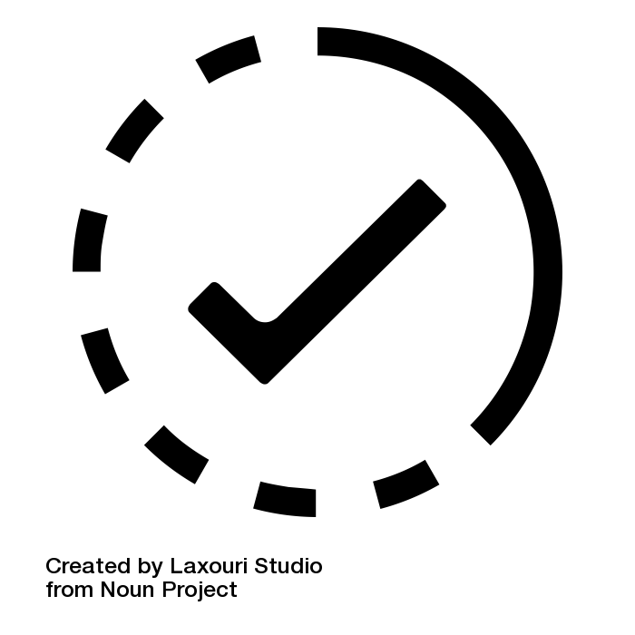
ASEE is ready for 2026.
With new money and new people working for ASEE,
ASEE will help more people find
and keep good jobs across Europe.

Easy-to-read text by Martina Bianco and Laura Jones.

Co-funded by the European Union. Views and opinions expressed are however those of the authors only and do not necessarily reflect those of the European Union or the European Commission. Neither the European Union nor the granting authority can be held responsible for them.

